First Computer 1943  
First Computer Program 1843 Ada Lovelace  
Declerative knowledge 🡪 y is the square root if and only if y*y=x  
Imperative knowledge 🡪 programs

**Fixed Program Computers**  
Abacus 500 BC  
Antikythera Mechanism 100 BC  
Pascaline 1642 Blaise Pascal + -  
Leibniz Wheel 1694 + - * /  
Jacquard’s Loom 1801 Punched cards   
Babbage Difference Engine 1832 Polynomial functions 8 numbers of 31 decimal digits 7th degree polynom  
The Hollerith Electric Tabulating System 1880 1500 people’s data for 7 years, punched cards for istatistic  
Computing Tabulating Recording Corporation (CTRC) 1900-1950 modern Hollerith company machine  
Atanasoff-Berry Computer (ABC) 1939 electronic digital linear equations  
Turing Bombe 1941🡪Enigma code breaker 🡪 Alan Turing The Father of computer science.Turing Award 1912-1954  
**Stored Program Computers**  
Babbage’s Analytical Engine 1834 punched cards for input, has all math computation, embodies elements of today’s pc, store 1000 registers of 50 digits each  
Ada Lovelace 🡪 first programmer. Described how the machine programmed to solve problems.  
The Zuse Z3 Computer 1941 original Z3 bombed ww2. Reconstrate at 1960s  
Colossus Mark 1 1944 First electronic digital with programmability.  
ENIAC 1946 electronic computer without any mechanichal part. Calculate artillery firing tables for US Army.  
EDVAC (Electronic Discrete Variable Automatic Computer) 1951 von Neumann. uses binary, stored in memory, conditional functions

What is general-purpose computer?  
Are there limits on power of digital computers?  
Are there limits on the power of machines we can build?  
David Hilbert, Kurt Gödel, Alan Turing, Alanso Church, John von Neumann  
What is knowledge?  
What is computer?  
What is program?  
History of computing.

0.0-0.5 🡪0 2.8-3.3🡪1

13=1.23+1.22+0.21+1.20==6.102+0.101+3.100=603  
=2.82+0.81+7.80=128+0+7=135  
A modern 64-bit computer can represent integers up to 264-1

On 8-bit 3=00000011 and -3 is flip and add 1 🡪 00000011 🡪 11111100 🡪 11111101 = -3  
8 bitte kesirli sayılarda 6 bit ini kesirli sayı için geri kalanı 10n için kullanılır. 🡪 Eğer 31415901 olursa   
0.314159 x 101 = 3.14159  
ANSI(American National Standarts Institute) established ASCII(American Standart Code for Information Interchange)  
chocolate = 99 104 111 99 111 108 97 116 101  
The International Standarts Organization(ISO) 16-bit Unicode 🡪 UTF8 🡪 A=U+0041  
🡪 yani “ise” = x’ + xy deneyelim 🡪 1->0 =0🡪 1’ + 1.0 = 0+0 = 0 altta da “ise”nin şeması var

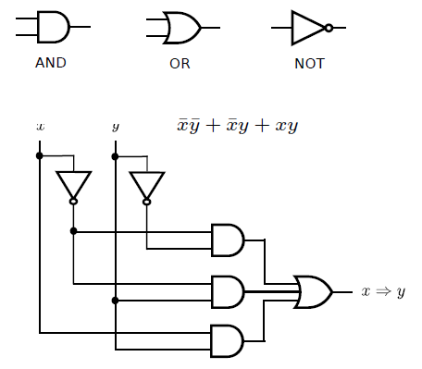

A truth table describing the addition of two two-bit numbers to get a three-bit result 🡪 Direk topla 11+11=110

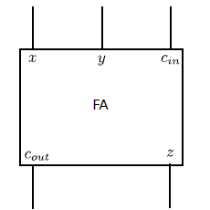

x y cin cout z

0 0 0 0 0  
0 0 1 0 1  
0 1 0 0 1  
0 1 1 1 0  
1 0 0 0 1  
1 0 1 1 0  
1 1 0 1 0  
1 1 1 1 1

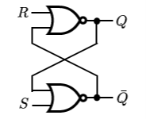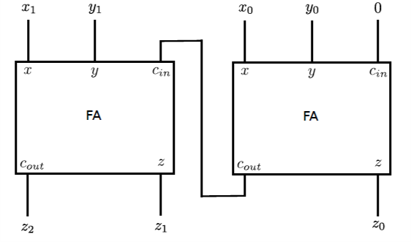

A 2-bit riplle-carry adder NOR gate

NOR gate is 0 nor 0 = 1, else 0  
RAM = Random Access Memory. Billion latches is 1 ram. Every latch is 1 bit. 0 or 1. Control Unit 🡪 Makes decisions and sends appropriate signal to other parts of PC.

Arithmetic/Logic Unit (ALU)🡪 Carries out all calculations and data sent to processor.

Register 🡪 Small memory in processor for fast access without any cable.  
BUS 🡪 Collection of paralel wires that carry adress, data and control signals

ALU + Control = Processor

in CPU has 2 special registers:   
Program Counter 🡪 Contains adress of instructions being executed or will execute.

Instruction Register 🡪 Read instructions from memory. Convert it to signals

von Neumann Architecture 🡪CPU nun temelini oluşturur.En eski CPU. 00(add) 01(sub) 10(mul) 11(div) olsun. r0+r2=r3 için 00110010 ya da 00111000 şeklinde kodlamalısın. Ya da r3-r2=r0 için 01001110 şeklinde kodlanır. 01(sub)00(r0)11(r3)10(r2).

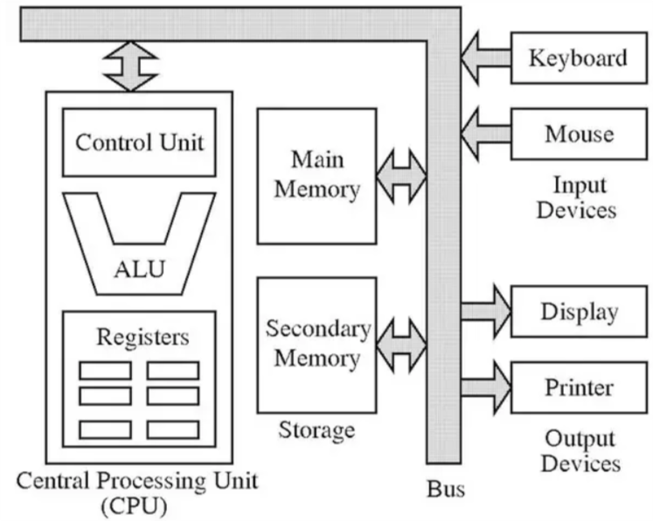

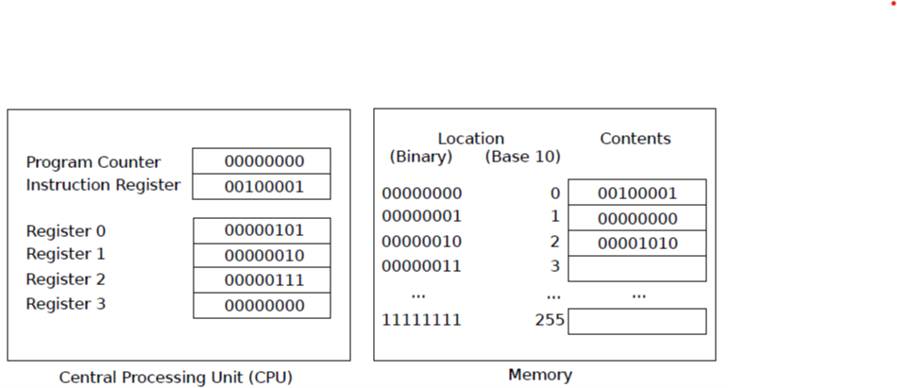

Read 🡪 0000 XXXX 0000 0001

Write 🡪 0000 XXXX 0000 0010

Add 🡪 0110 XXXX XXXX XXXX

Sub 🡪 0111 XXXX XXXX XXXX

Mul 🡪 1000 XXXX XXXX XXXX

Div 🡪 1001 XXXX XXXX XXXX

Setn 🡪 0001 XXXX NNNN NNNN 🡪 8 bit sayı yoksa overflow

Jumpn N

Calln rX N bir sonraki satırın numarasını rX e esitler ve N. Satıra atlar.

Jumpr rX rX in değeri olduğu satıra geri doner. Genelde rX r14 olur.

Jeqzn rX N rX 0 a esitse suraya atla

Jnezn rX N

Jgtzn rX N

Jltzn rX N

Copy rX rY rX=rY

Neg rX rY rX=-rY

Mod rX rY rZ rX=rY%rZ

Storen rX N

Loadn rX N

Loadr rX rY

Storer rX rY

Syntax 🡪 sözdizimi hatası

Semantics 🡪 mantık hatası

Python 🡪 interpreter 🡪 boolean hale döndürmeden direk çalıştırır.

C 🡪 compiler 🡪 çalışmadan önce boolean hale döndürülür. Daha hızlıdır.